**Gif Importer**

**Introduction:**

This plugin’s purpose is to give Unity the ability to import a .gif file as an animation, by converting the raw .gif file into sprite sheets and then generate the animation from it.

In order to read the data from the .gif file, System.Drawing.dll needs to be included under “Assets\Plugins\”.

The original file is found under “%UnityFolder%\Editor\Data\Mono\lib\mono\2.0\”.

User may replace it with a later version as they see fit.

This plugin consists of 1 script named “Gif2Sprite.cs”, located under “Assets\Scripts\Editor”.

**Usage:**

When the user drag a .gif file into a folder named “gif2sprite”[1], an import window will prompt the user with some import options.

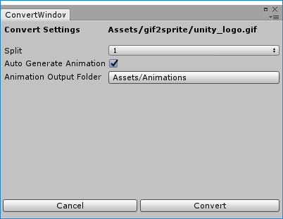

**Split**

Number of sprite sheets to generate, sometimes the source file is too large in resolution, resulting large sprite sheets that would get compressed and hence lower the quality of the final animation.

**Auto Generate Animation**

Should the importer generate the animation file automatically after creating the sprite sheet.

**Animation Output Folder**

Specify the output path of the animation file.

1. Can be modified at line 143 of Gif2Sprite.cs